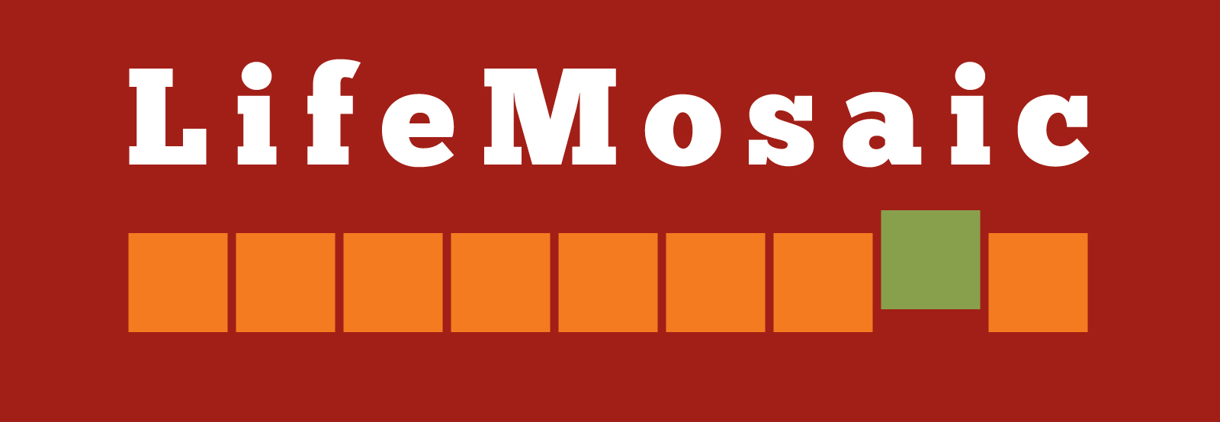

Application Form

To apply, please send in the answers to ALL of the questions below and send with your curriculum vitae to job@lifemosaic.net by 16 August 2021.
Please answer all questions within the specified word count.

Job Title: Programme Officer – Supporting indigenous movements in Indonesia

LifeMosaic is looking for a Programme Officer to support indigenous movements in Indonesia. This is a one-year contract (with possible extension) with an initial 3-month trial period. This post will be based in Jakarta or Bogor. This is a unique opportunity to join a small and dedicated team, working with partners across Indonesia, supporting local communities, partners, and facilitators to empower indigenous communities by using popular education resources and approaches.

Deadline for applications – 16 August 2021. Sent to job@lifemosaic.net
Interview date – 23 August 2021.

Name:
Address:
Telephone:
Email / Skype:

Describe your experience working on issues relating to indigenous peoples’ rights, land rights, forests. (Maximum 200 words)

Describe your experience in project planning and implementation and organisational skills.
(Maximum 150 words)

Describe your networks within the Indonesian and international indigenous peoples’ rights,
land rights, and forests movements. (Maximum 150 words)

Please describe your experience in facilitation and training of trainers. (Maximum 200 words)

What are your reasons for applying for this job? (Maximum 100 words)

Present employment: (Maximum 50 words)

Relevant education:

Languages (include level of proficiency):

Past salary history:

Please provide us with contact details for 2 referees:

When would you be available to start working in this post?

If selected, are you available for interview on the 23 August 2021?

Please send your completed application and your curriculum vitae to job@lifemosaic.net

